# Homework 1 Report (Yunke Tian – 109929662)

## Problem 1

What I did:

I wrote a very simple android program (as I’m totally new to it), where I press the “start” button and it starts to scan the connection wifi signal strength. I tested indoor with NLOS, and outdoor of LOS, with 1020 data each, and 3 seconds of scan interval. The data were written to .txt files in my android mobile, and I use thirdparty app to send it to my laptop for processing.

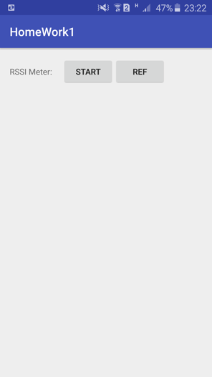

Result & discussion:

Below are the indoor noise and outdoor noise histogram:

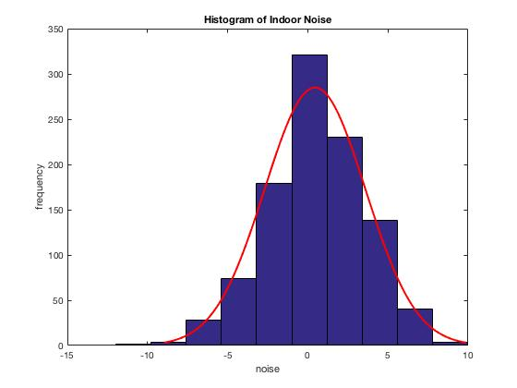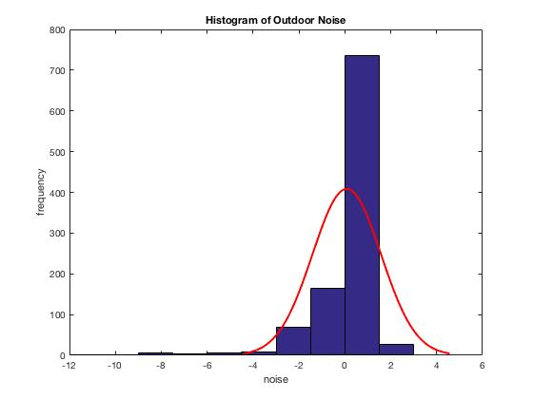

Indoor Outdoor

From the figures, it’s obvious that indoor noise has larger variance, while outdoor noise is more centralized to 0 with smaller variance. This mainly results from the shadowing/fading source.

Source Code:

Main files are in the “android_code” directory.

## Problem 2

What I did:

Exactly according to the assignment instructions. All codes implemented in MatLab.

Result & discussion:

1. Heatmap as follows:

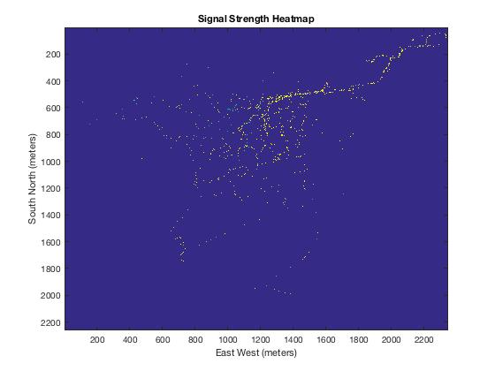

1. The closer to the base station, the stronger the signal strength. It’s like a wave spreading out.
2. RSSI – log(dist) plot for 6 base stations (7838, 6232, 6233, 6231, 7837, 5338): (I used log10)

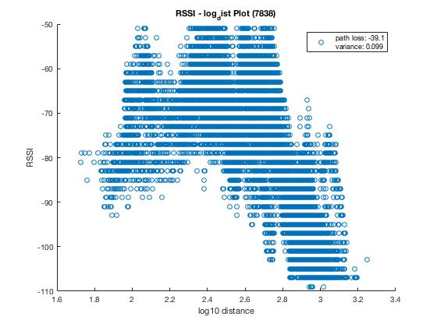 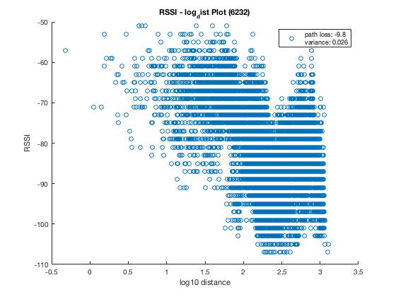

7838 6232

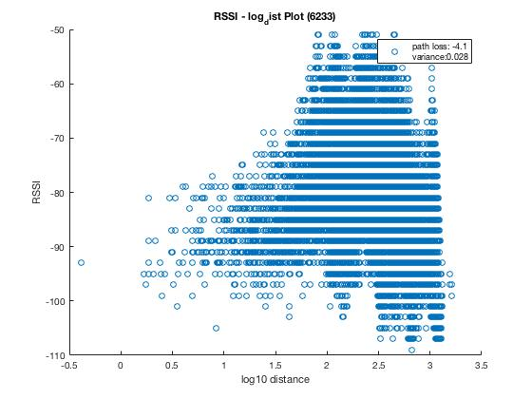 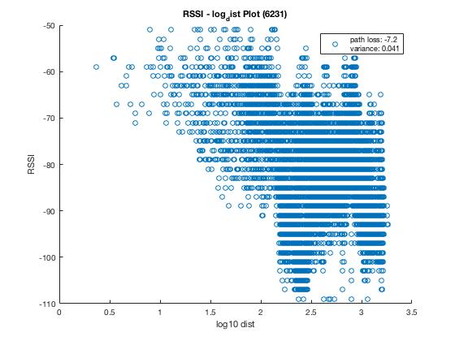

6233 6231

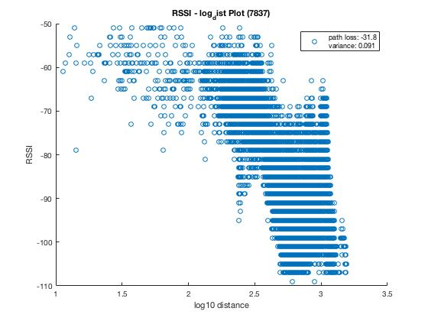 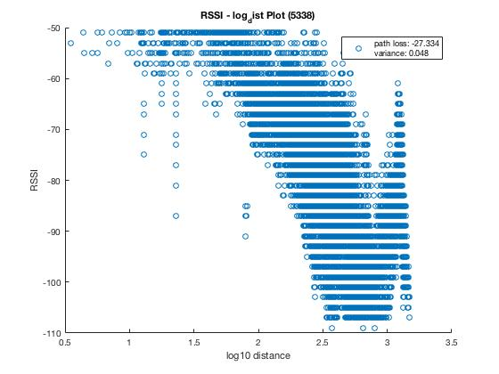

7837 5338

d. Path loss exponent Shadowing variance

7838 -39.1 0.099

6232 -9.8 0.026

6233 -4.1 0.028

6231 -7.2 0.041

7838 -31.8 0.091

5338 -27.3 0.048

Source Code:

Codes for problem 1 and problem 2 are in corresponding folders in “matlab_code” directory. For problem 1, run ‘prob_main.m; for problem 2, run ‘htMap.m’ and ‘scatterPlot.m’.